Grafana is a great tool to visualize timeseries data, but it’s also capable of displaying database data. We only need SQL query to make it work.

**Installation and setup mysql connection**

1: install grafana: for mac, brew install grafana; for windows, download grafana, unzip, and append to PATH

2: install pie chart plugin by typing command: grafana-cli plugins install grafana-piechart-panel

3: start grafana by typing: grafana-server

4: in the browser, type localhost:3000 to the page

5: in the home dashboard, click create your first datasource

6: choose the type to be “mysql”, then set up the localhost connection

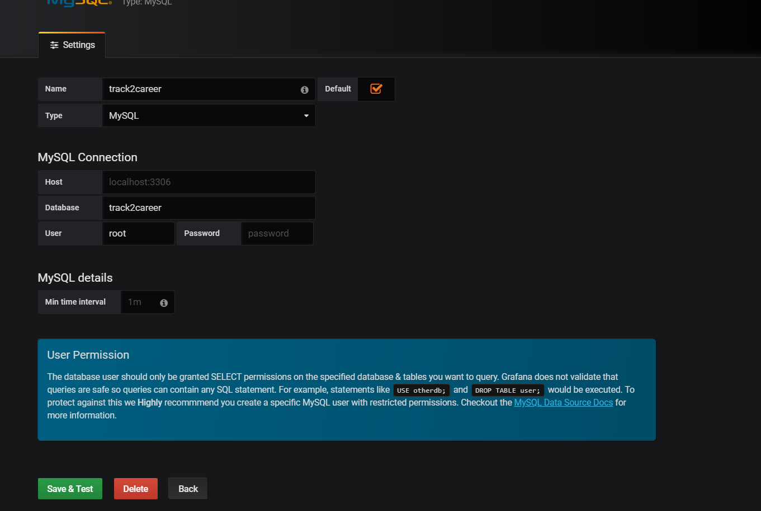

**Insert random data to database (for users and website usage)**

1. Create a new table to record user access information, syntax: create table accessdetails (accesstime datetime, user_id varchar(50), accessedtrack varchar(50))
2. Insert 1000 random users using randonUserGenerator.py(the program generates 1000 random users based on the distribution 60%SMU, 20% other universities, 5%JC, 10% poly and 5% international, they are assigned 10% chance of admin. All the rest fields are randomly generated)
3. Insert 10000 random user access records in the newly created table. Use script randomUsage Generator.py. The script generates random access to different tracks from 2018-11-29 to the moment the script is run. The distributions are equal.

**Fast import existing dashboards in .json file.**

1. Hover on the + sign at the left of homepage, click import
2. Click upload .json file, select the file I sent
3. If they ask you to choose the database, select our mysql one
4. Done!